Hello!

Thank you for your interest in eTutoring.org. This document will show you how to sign in to the “CTDLC eTutor Training Institute” at [www.etutoring.org](http://www.etutoring.org). This Training Institute was set up so you could explore the site on your own. You’ll see the site almost exactly as your students will see it, but the Training Institute is not connected to any of our tutors, so you won’t be able to interact with a tutor in a live eChat session. Nor will you receive a response email if you post a paper on the test site. Still, it provides a good preliminary look at the site because you can wander through the site and go through all of the same processes your students will go through when they use the site.

To proceed, go to [www.etutoring.org](http://www.etutoring.org) and click on the “Login Now!” button.



Then you should see the screen shown below.

Select the “CTDLC eTutor Training Institute,” the last one on the Consortium list.

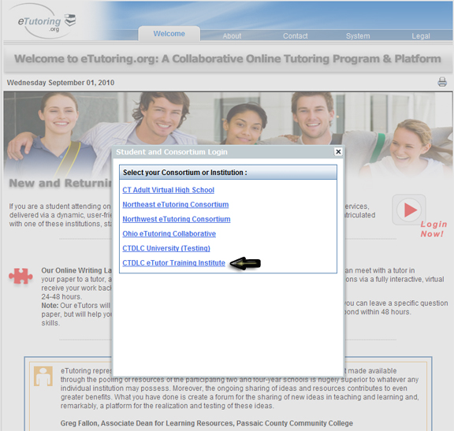

You should then arrive at the page below.

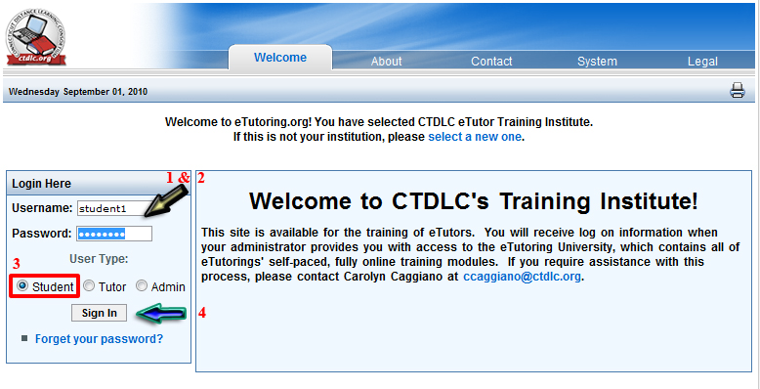

Use the following username and password to log in (steps one and two in the screenshot above):

Username: student1

Password: password

Next (step three in the screenshot above), make sure “Student” is selected.

Push the “Sign In” Button to complete the login process (step four in the screenshot above).

Please note that you’ll be able to see and do everything a student can do, but because this is a test account, the tutors will not see or respond to anything you submit.  However, this site is almost an exact replica of the live student site, so it will give you a very good idea of the typical student’s experience with the site.

Please explore every aspect of the site that interests you and feel free to send any questions you might have to Sarah Bergfeld, the Executive Coordinator of the NWeTC, at [sbergfeld@wsu.edu](mailto:sbergfeld@wsu.edu) or call her at 509-335-5157.

Enjoy your tour!