Portland Community College
Sylvania Campus
ESOL 20: Level 2 Integrated Skills CRN: 26178
Spring Term 2026 (April 6th, 2025 – June 14th, 2025)
Our classroom: Zoom
Teacher: Blake Hamilton
Class Days: We have class three days a week: Monday, Wednesday, and Thursday evenings from 6:00 pm – 8:50 pm.
Availability: I’m usually available all week. Please message me on WhatsApp if you have any questions or you want to talk to me.
Email: blake.hamilton@pcc.edu

Phone: 971-221-5160 (You can call, text, or message me on WhatsApp.)
Class website: https://www.pcc.edu/staff/blake-hamilton/ - This is where I will post information from class, including homework.
WhatsApp: Join our WhatsApp Group! I will post homework and reminders every week.
Extra help: If you have questions or need extra help outside of class, I can help you. You can email or text me and we can set up an appointment.
Important dates for our class:
- No class on Monday, May 25th. PCC will be closed for Memorial Day.

Homework: We have homework on Monday and Thursday. Homework is due the next class day. Homework will be posted on WhatsApp.
Grading: We will be studying reading, writing, speaking, and listening in this class. You must get 70% or higher in each skill to move up to level 3. Most students stay in level 2 for two or three terms.
Materials: You will need a pencil/pen, paper, a textbook and a laptop/computer.
Computer
Textbook

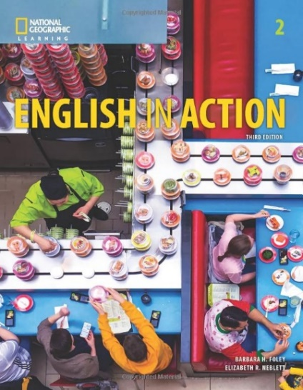

Buying a Textbook:
You can get a textbook in two different ways:
- Buy it at the PCC Bookstore
- Buy it on Amazon.

If you can’t afford a textbook, message me on WhatsApp.
Borrowing a Laptop:
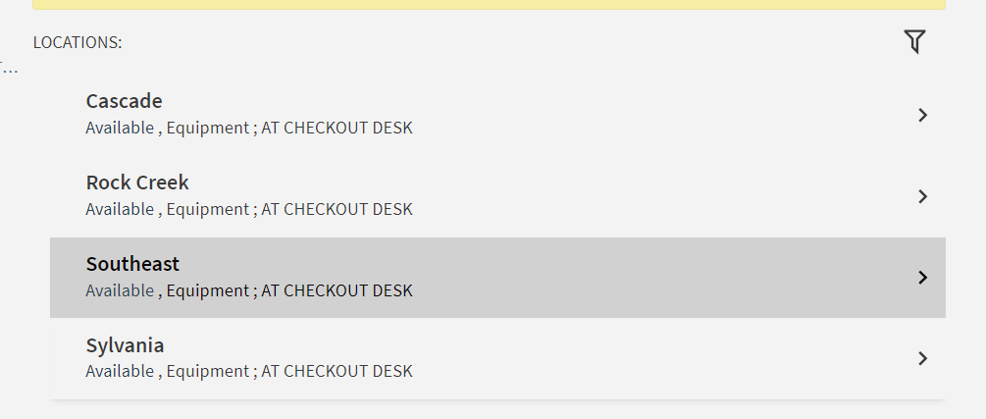
Don’t take this class on your phone! If you don’t have a computer or laptop, you can borrow a laptop from the PCC Library for the entire term then return it at the end of spring term. Have an English-speaking friend or your teacher help you borrow a Chromebook from the library for free! Library Link

Attendance: Please come to class every day. Come on time at 6:30pm if you can.
If you can’t come to class, please call, text, or email me.

Hello Blake, this is ________________________________________ .
I can’t come to class today because __________________________.

I am sick
My child is sick
I have an appointment
I have to work
I will see you on _______________.

Paying for Class: The class costs $129.20. Students who receive OHP or Food Stamps/SNAP don’t have to pay for the class. Please show your documentation to the teacher if you receive OHP or SNAP. If you need help paying for the class, please talk to me after class. If you do not want this class, please message the teacher by Friday, April 10th to get a refund.

ADA Statement: If you have any specific needs, please let me know on the first day of class.
​PCC is a sanctuary college. For more information and resources, see www.pcc.edu/resources/undocumented-students/
Title IX/Non-Discrimination statement: PCC is committed to creating and fostering a learning and working environment based on open communication and mutual respect. If you believe you have encountered sexual harassment, sexual misconduct, sexual assault, or discrimination based on race, color, religion, age, national origin, veteran status, sex, sexual orientation, gender identity, or disability please contact the Office of Equity and Inclusion at (971) 722-5840 or equity.inclusion@pcc.edu.
Use your own words! You can read the Code of Student Conduct and the Academic Integrity Policy at www.pcc.edu/about/policy/student-rights

