Portland Community College
Sylvania Campus
ESOL 20: Level 2 Integrated Skills CRN: 40372
Fall Term 2025 (September 22nd, 2025 – December 8th, 2025)
Our classroom: CT 108
Teacher: Blake Hamilton
Class Days: We have class three days a week: Monday, Wednesday, and Thursday evenings from 6:30pm – 9:20 pm.

Office: My office is in CT 207. I’m in the office from 6:00pm to 6:30pm before class.
Email: blake.hamilton@pcc.edu
Phone: 971-221-5160 (You can call, text, or message me on WhatsApp.)
Class website: https://www.pcc.edu/staff/blake-hamilton/ - This is where I will post information from class, including homework.
WhatsApp: Join our WhatsApp Group! I will post homework and reminders every week.
Extra help: If you have questions or need extra help outside of class, I can help you. You can email or text me and we can arrange an appointment.
Homework: We have homework on Monday and Thursday. Homework is due the next class day. Tell me if you need more time to do your homework.
Grading: We will be studying reading, writing, speaking, and listening in this class. You must get 70% or higher in each skill to move up to level 3. Most students stay in level 2 for two or three terms.
Materials: You will need a binder, pencil/pen, paper, and our class textbook.
Binder
Textbook

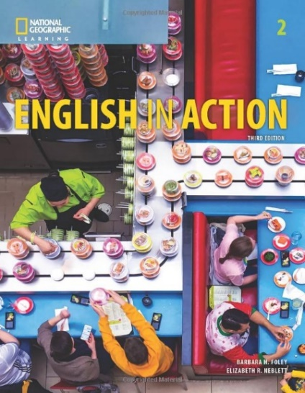

You can buy our class textbook at the PCC bookstore. It costs about $35. If you can't pay for the book, you can borrow one for free. You must return the book at the end of the term. You can't write in the book.

Attendance: Please come to class every day. Come on time at 6:30pm if you can.
If you can’t come to class, please call, text, or email me.

Hello Blake, this is ________________________________________ .
I can’t come to class today because __________________________.

I am sick
My child is sick
I have an appointment
I have to work
I will see you on _______________.

Paying for Class: The class costs $124.70. Students who receive OHP or Food Stamps/SNAP don’t have to pay for the class. Please show your documentation to the teacher if you receive OHP or SNAP. If you need help paying for the class, please talk to me after class.
ADA Statement: If you have any specific needs, please let me know on the first day of class.
​PCC is a sanctuary college. For more information and resources, see www.pcc.edu/resources/undocumented-students/
Title IX/Non-Discrimination statement: PCC is committed to creating and fostering a learning and working environment based on open communication and mutual respect. If you believe you have encountered sexual harassment, sexual misconduct, sexual assault, or discrimination based on race, color, religion, age, national origin, veteran status, sex, sexual orientation, gender identity, or disability please contact the Office of Equity and Inclusion at (971) 722-5840 or equity.inclusion@pcc.edu.
Use your own words! You can read the Code of Student Conduct and the Academic Integrity Policy at www.pcc.edu/about/policy/student-rights

