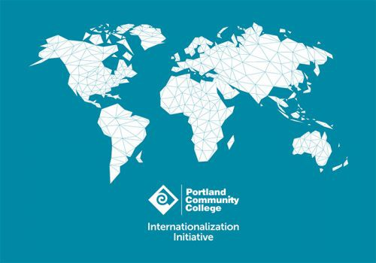
Application for Professional Development

Grant in Internationalization

Internationalization Steering Committee (ISC), part of the Internationalization Initiative at PCC

Name: ___________________________
Department: Campus:
Course that you propose to internationalize: _______________________
First term you expect to teach with the new curriculum:
Email: _______________ Phone: ______________
(number that will work during campus closure)
Check one: □FT faculty □PT faculty
- Projects can be modification of course materials, new course materials, or another project that adds an internationalization component or international focus to a course. We encourage you to be creative!
- Projects must be an addition or modification to an existing course. We cannot fund new course development, projects that do not relate to a particular course, or projects for courses that are not currently being taught.
- These grants are intended to encourage internationalization of courses that are not already international by design (“international” means outside of the boundaries of the United States).
- Applicants will be asked to provide learning objective/outcomes, a detailed outline of classroom methodologies/activities and a list of products proposed.
- Applicants will be expected to prepare curriculum materials that can also be used by other instructors.
- Applicants will be expected to teach using the new materials within one year of project completion.
- Priority will be given to funding applicants that have not received funding from ISC before.
- Curriculum, application materials and reports developed under this grant become property of PCC and may be used as examples for future grant applications, on the PCC website, or otherwise shared inside or outside of PCC.
- Applicants will be expected to present about their project at a future meeting, to be determined in collaboration with the ISC (Internationalization Steering Committee).
- Applications will be reviewed, and awards determined by members of the ISC.
- Payment will be made after the project is completed and copies of the curriculum that was developed are submitted.
- Applicants are encouraged to ask for feedback while creating their application.
- The award amount is $500.
- All work must be completed by Sunday, May 19, 2024.
Please answer the questions on the next page. Add space or pages as needed.

  - Title of Project
  - Course you propose to Internationalize
  - Description of project (summary)

  - Details of the project

    - Outcomes/learning objectives
    - Detailed outline of classroom methodologies/activities, including any products produced by the students
    - Curriculum products you plan to develop
    - How will you assess whether the objectives were met?
  - Please provide a brief answer to each of the following:

    - Is this project replicable? (preference will be given to projects that can be used in more than one course or by more than one instructor). Please explain.

    - How would you be able to share what you have done with other faculty at PCC?

    - Is there anything in your background or experience that will help you to accomplish this project?

Please email your completed application to: Robert Asaadi, ISC Chair, robert.asaadi@pcc.edu

